ALLINGTON GARDENS PARK
Allington, Grantham
Lincs NG32 2FL

Residential Park for 50+

203 Pitches (approx)
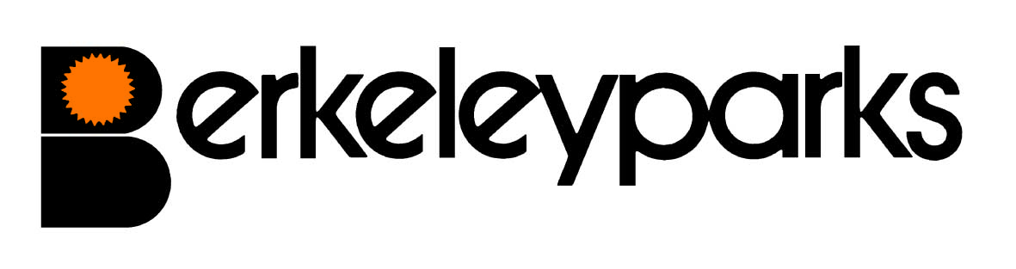
Park Managers | Robert Maltby & Claire Kitchen Park Office: 01400 282033
Park Office Hours | Monday to Friday 9.00 am - 1.00 pm & 2.00 pm - 4.00 pm  Other times by appointment
Pitch Fees | For new homes: £186.00 Due on the first day of each month at the park office or by Direct Debit. Reviewed on 1st January each year.
Council Tax | Band A at £1,193.82 per annum.
Water/Sewerage | Payable at the park office or by monthly Direct Debit.
Gas | Mains gas charged direct by supplier or LP gas available direct from your own supplier (dependent on plot).
Electricity | Payable at the park office or by monthly Direct Debit.
Home Insurance | All homes must be insured.
Pets | One dog or one cat only per home would be considered.
Refuse Collection | Dustbins and recycling boxes are emptied every other Friday and garden waste every other Monday.
Public Transport | Call Connect bus service available. Main line train services run from Grantham.
Park Facilities | Milk, bread and groceries are delivered to the park. Mobile Library, Hairdresser, Pet Groomer and Gardener call at the park.
Local Facilities | Post Office and Pub are in the village. Doctors Surgery is nearby. Supermarkets, banks, building societies, Post Office, Hospital and shops are in Grantham. Caravan storage is nearby.
Park Rules | All residential park homes have the benefit of a Written Statement under The Mobile Homes Act 2013 (previously The Mobile Homes Act 1983 as amended by the Housing Act 2004). A specimen copy of this agreement is available on request. The agreement contains Park Rules to ensure the good management of the park.
This information is correct at January 2021. Every effort has been made to ensure the information provided above is accurate. However, we cannot accept liability for changes, errors or unintended misinformation. Please check locally for up to date details prior to proceeding with your purchase, particularly with regard to any aspect important to you.

