FELL VIEW PARK
Gosforth
Cumbria CA20 1HY

Residential Park for 50+

85 Pitches (approx)
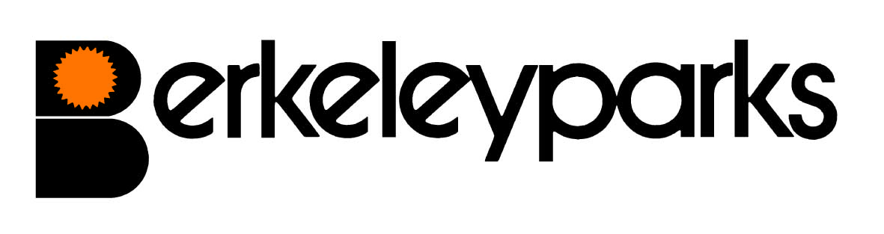
Park Managers | Ralph & Hazel Jacklin Park Office: 01946 725121
Park Office Hours | Monday to Friday 9.00 am - 1.00 pm  Other times by appointment
Pitch Fees | For new homes: £148.00 Due on the first day of each month at the park office or by Direct Debit. Reviewed on 1st January each year.
Council Tax | Band A at £1,309.97 per annum.
Water/Sewerage | Charged direct by supplier.
Gas | Mains gas charged direct by supplier.
Electricity | Payable at the park office or by Direct Debit.
Home Insurance | All homes must be insured.
Pets | One dog or one cat only per home would be considered.
Refuse Collection | Dustbins are emptied every other Wednesday. Black bins and recycle bins one Wednesday and the brown garden bin the following Wednesday.
Public Transport | On Thursday mornings a bus goes from the park to Tesco & Morrisons in Whitehaven.
Park Facilities | Milk is delivered daily and pet food once a week.
Local Facilities | Church, Library, Village Hall, garage, mobile hairdresser, shops, bakery, restaurants & pubs are in the village.
Park Rules | All residential park homes have the benefit of a Written Statement under The Mobile Homes Act 2013 (previously The Mobile Homes Act 1983 as amended by the Housing Act 2004). A specimen copy of this agreement is available on request. The agreement contains Park Rules to ensure the good management of the park.
This information is correct at January 2021. Every effort has been made to ensure the information provided above is accurate. However, we cannot accept liability for changes, errors or unintended misinformation. Please check locally for up to date details prior to proceeding with your purchase, particularly with regard to any aspect important to you.

