SELWOOD PARK
Weymans Avenue, Kinson
Bournemouth, Dorset BH10 7JU

Residential Park for 50+

100 Pitches (approx)
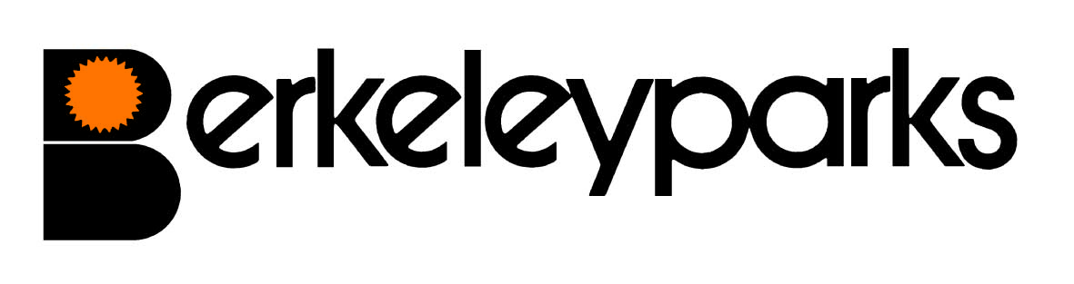
Park Manager | Paul Clarke Park Office: 01202 590490
Park Office Hours | Monday to Friday 9am - 12.00pm
Pitch Fees | Due on the first day of each month at the park office or by Direct Debit/Standing Order. Reviewed on 1st January each year.
Council Tax | Band A.
Water/Sewerage | Payable at the park office or by Direct Debit/Standing Order.
Gas | Mains gas charged direct by supplier.
Electricity | Payable at the park office or by Direct Debit/Standing Order.
Home Insurance | All homes must be insured.
Pets | One dog or one cat only per home would be considered.
Refuse Collection | Dustbins are emptied every Friday and recycling boxes every other Friday.
Public Transport | Buses to Bournemouth main line rail services and Poole stop near the park.
Local Facilities | Doctors Surgery, Post Office, Library, Tesco supermarket & shops are in walking distance.
Park Rules | All residential park homes have the benefit of a Written Statement under The Mobile Homes Act 2013 (previously The Mobile Homes Act 1983 as amended by the Housing Act 2004). A specimen copy of this agreement is available on request. The agreement contains Park Rules to ensure the good management of the park.
This information is correct at February 2023. Every effort has been made to ensure the information provided above is accurate. However, we cannot accept liability for changes, errors or unintended misinformation. Please check locally for up to date details prior to proceeding with your purchase, particularly with regard to any aspect important to you.

