CLIFF TOP PARK
Selby Road, Garforth
Leeds LS25 2PA

Residential Park for 50+

73 Pitches (approx)
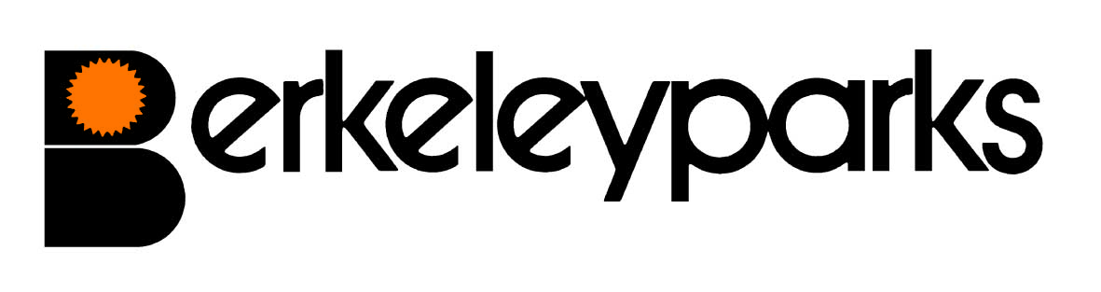
Park Managers | Annette Flather & Michael Sheppard Park Office: 0113 286 5246
Park Office Hours | Wednesday 9.00 am - 3.00 pm  Other times by appointment
Pitch Fees | Due on the first day of each month at the park office or by Direct Debit/Standing Order. Reviewed on 1st June each year.
Council Tax | Band A.
Water/Sewerage | Payable at the park office or by Direct Debit/Standing Order.
Gas | Mains or LPG gas charged direct by supplier.
Electricity | Payable at the park office or by Direct Debit/Standing Order.
Home Insurance | All homes must be insured.
Pets | Pets are not accepted.
Refuse Collection | Dustbins are emptied every Monday and recycling boxes are emptied every 4 weeks on Tuesday.
Public Transport | Bus runs every two hours from park into Garforth. Buses run from outside the park to Leeds. Main line train services run from Garforth and East Garforth to Leeds and Hull.
Park Facilities | A mobile library calls every Saturday morning.
Local Facilities | Doctors Surgery, chemist, banks and supermarkets are in Garforth.
Park Rules | All residential park homes have the benefit of a Written Statement under The Mobile Homes Act 2013 (previously The Mobile Homes Act 1983 as amended by the Housing Act 2004). A specimen copy of this agreement is available on request. The agreement contains Park Rules to ensure the good management of the park.
This information is correct at March 2023. Every effort has been made to ensure the information provided above is accurate. However, we cannot accept liability for changes, errors or unintended misinformation. Please check locally for up to date details prior to proceeding with your purchase, particularly with regard to any aspect important to you.

