LION HOUSE PARK
Mill Road, Hailsham
Sussex BN27 2SE

Residential Park for 50+

166 Pitches (approx)
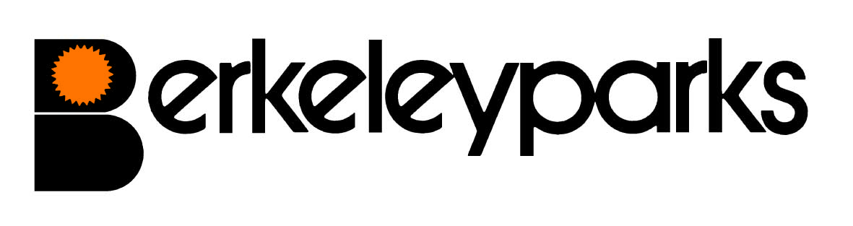
Office Administrator | Jayne Shoesmith Park Office: 01323 840059
Park Office Hours | Monday to Wednesday 9.30 am – 3.00 pm  Other times by appointment
Pitch Fees | Due on the first day of each month at the park office or by Direct Debit/Standing Order. Reviewed on 1st January each year.
Council Tax | Band A.
Water/Sewerage | Payable at the park office or by Direct Debit/Standing Order. Sewerage charged direct by supplier.
Gas | Mains gas charged direct by supplier.
Electricity | Payable at the park office or by Direct Debit/Standing Order.
Home Insurance | All homes must be insured.
Pets | Pets are not accepted.
Refuse Collection | Dustbins and recycling boxes are emptied every other Wednesday.  Garden waste alternative Fridays.
Public Transport | Buses to Hailsham run from the park.
Park Facilities | Residents Club.
Local Facilities | Doctors Surgery, supermarket & weekly market are in the town.
Park Rules | All residential park homes have the benefit of a Written Statement under The Mobile Homes Act 2013 (previously The Mobile Homes Act 1983 as amended by the Housing Act 2004). A specimen copy of this agreement is available on request. The agreement contains Park Rules to ensure the good management of the park.
This information is correct at March 2023. Every effort has been made to ensure the information provided above is accurate. However, we cannot accept liability for changes, errors or unintended misinformation. Please check locally for up to date details prior to proceeding with your purchase, particularly with regard to any aspect important to you.

