HAM MANOR PARK
Llantwit Major
Vale of Glamorgan CF61 1BA

Residential Park for 50+

108 Pitches (approx)
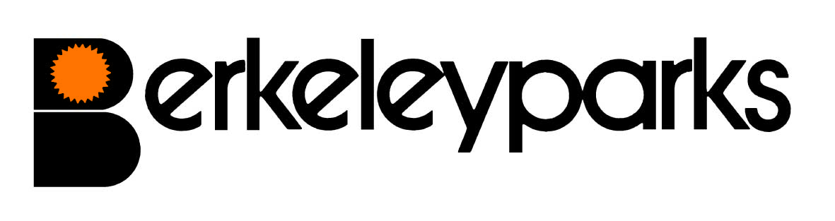
Park Manager | Mark Snowden Park Office: 01446 792187
Park Office Hours | Monday to Friday 9.00 am - 1.00 pm & 2pm – 4.00pm  Other times by appointment
Pitch Fees | Due on the first day of each month at the park office or by Direct Debit/Standing Order. Reviewed on 1st January each year.
Council Tax | Band A, Band B, Band C or Band D.
Water/Sewerage | Payable at the park office or by Direct Debit/Standing Order.
Gas | LPG gas available via your own supplier.
Electricity | Payable at the park office or by Direct Debit/Standing Order.
Home Insurance | All homes must be insured.
Pets | One dog or one cat only per home would be considered.
Refuse Collection | Dustbins and recycling boxes are emptied every Monday.
Public Transport | Buses and main line rail services run from the town.
Park Facilities | Milk & newspapers are delivered daily and local food deliveries. Hairdresser and Chiropodist will call by appointment.
Local Facilities | Doctors Surgery, Dentist, Library, and a variety of shops and supermarkets are in the town.
Park Rules | All residential park homes have the benefit of a Written Statement under The Mobile Homes Act 2013 (previously The Mobile Homes Act 1983 as amended by the Housing Act 2004). A specimen copy of this agreement is available on request. The agreement contains Park Rules to ensure the good management of the park.
This information is correct at March 2023. Every effort has been made to ensure the information provided above is accurate. However, we cannot accept liability for changes, errors or unintended misinformation. Please check locally for up to date details prior to proceeding with your purchase, particularly with regard to any aspect important to you.

